[Note: You have permission to use this article in its entirety or to take segments/snippets as long as you include my byline shown below as is:
©2026, copyright Thomas MacEntee. All rights reserved. For more information, please visit Genealogy Bargains at https://genealogybargains.com.]

America 250 doesn't need a minute. It needs a bunch of them.
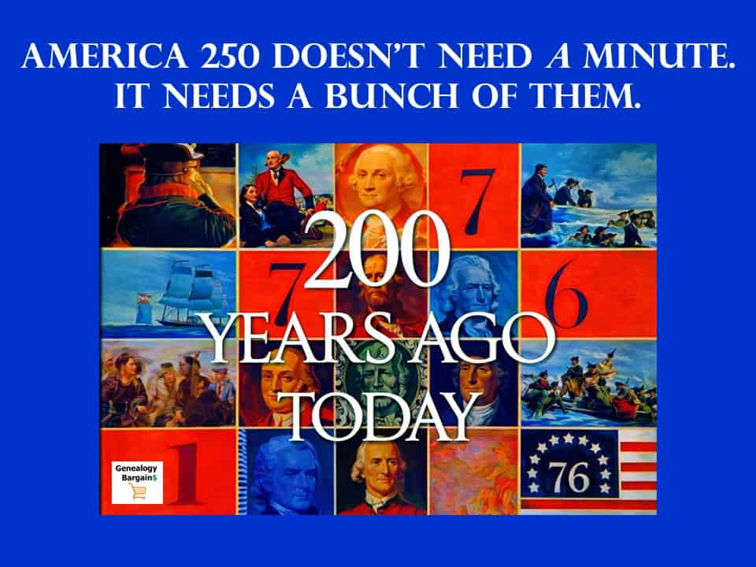
I was 13 in 1976, which is an age when you're beginning to suspect that adults aren't running everything with calm competence. And television is still basically your second parent, except this parent could sell you sugary cereal and also tell you, for sixty seconds, about the American Revolution.
The thing I remember is the "Bicentennial Minute." A recognizable person would turn up in prime time and say: "Two hundred years ago today..." and then you'd get a small historical story, short enough to fit between your show and the next commercial. The stories weren't especially edgy or comprehensive. They were just... there. Regular. Un-fancy. Repetitive in the way rituals are repetitive, which is sort of the point of rituals.

America 250: What Made Those Bicentennial Minutes Work
Let me tell you what made those segments so special. It wasn't just that they were everywhere, though they certainly were. All three networks—ABC, CBS, and NBC—ran them. You literally couldn't watch television in 1976 without seeing multiple Bicentennial Minutes every single day.
What really made them work was the incredible variety of people who narrated them.
I remember seeing Walter Cronkite, of course—the most trusted man in America at the time. But I also remember being surprised by some of the other narrators. Muhammad Ali did one. So did Barry Goldwater. Think about that for a second. Muhammad Ali, who'd been vilified for refusing to serve in Vietnam, and Barry Goldwater, the conservative icon. Both of them telling American history stories, both of them participating in the same national project.
The list went on and on:
- Lucille Ball brought her charm to discussing colonial events
- Johnny Cash's distinctive voice narrated Revolutionary War moments
- Hank Aaron, who'd just broken Babe Ruth's record amid terrible racism, shared historical facts
- Leonard Bernstein lent his cultural gravitas to the project
- Regular soldiers, astronauts, and everyday Americans got their turn too
This wasn't some cynical diversity checkbox exercise. The producers genuinely brought together people from completely different worlds—different races, different political parties, different professions—and had them all tell the same American story.
And here's the thing that amazes me most when I look back: nobody made it controversial. Barry Goldwater's segment wasn't a conservative take on history. Muhammad Ali's wasn't a radical reframing of America's past. They were just historical facts, delivered by people we recognized and mostly trusted.

America 250: We All Watched the Same Three Channels
Here's something that's hard to explain to younger genealogists who've grown up with the internet: In 1976, we didn't have choices about media consumption. I mean, we had some choices, but nothing like today.
You turned on the TV, and you had three options. ABC, CBS, or NBC. That was it. Maybe you got a fuzzy PBS signal if you were lucky. Some people could pick up a local independent station. But for the most part, if you wanted to watch television, you were watching what everyone else was watching.
This created something we've completely lost today. When the Bicentennial Minutes aired during prime time, millions upon millions of Americans saw them at exactly the same moment. My family in Illinois saw the same segment that your family saw, wherever you were. We all had that shared experience.
I talk to younger genealogy researchers, and they don't quite grasp how different this was. They've grown up in a world where you can watch whatever you want, whenever you want, on whatever device you want. The idea that everyone watched the same thing at the same time seems bizarre to them.
But that's exactly what made the Bicentennial Minute possible. The networks had a captive audience. When they decided to run these segments, they knew they'd reach almost everyone who was watching television.

America 250: The Media Landscape Has Exploded
Now let me ask you: Where would you even put an America 250 Minute today?
Broadcast TV? Sure, you could try, but who's watching? The average age of a broadcast TV viewer keeps climbing. You'd mostly reach people like me—Baby Boomers who still have the TV on while we're cooking dinner or doing paperwork.
Streaming services? Which ones? Netflix, Hulu, Amazon Prime, Disney+, Paramount+, Max, Apple TV+? And even if you got all of them to agree to run your segments—good luck with that—their whole business model is based on letting people avoid interruptions. That's why people pay for streaming.
YouTube? Maybe, but then you're competing with millions of other videos, and you're at the mercy of an algorithm that shows people more of what they've already watched. Your America 250 segment might go viral in some circles and be completely invisible in others.
Social media? Same problem, but worse. Facebook's algorithm is designed to show you content from people you agree with and topics you're already interested in. Twitter—or X, or whatever we're calling it this week—is just shouting into the void. TikTok is so personalized that two people could be on the platform simultaneously and see completely different content.
I've spent years teaching people how to use technology for genealogy research, and I can tell you: there's no longer any way to create a truly shared media experience. We've fragmented into a million different audiences, all-consuming different content on different platforms at different times.

America 250: History Has Become a Battlefield
But here's the harder truth, the one that makes me uncomfortable to admit: Even if we could create a shared media experience, I'm not sure we could agree on what to say.
In 1976, the Bicentennial Minute producers could script a segment about the signing of the Declaration of Independence without controversy. It was just history. Here are the facts. Here's what happened. The end.
Try doing that today. I dare you.
Any America 250 campaign would immediately face questions that didn't exist—or at least weren't asked publicly—fifty years ago. I've seen these debates play out at historical societies, in genealogy groups, on social media, and at family reunions:
How do we talk about the Founding Fathers when many of them owned slaves? Do we mention it? How prominently? Does it overshadow their other accomplishments? Or is ignoring it dishonest?
What about the women who were excluded from political participation? The Native Americans whose land was taken? The enslaved people whose labor built much of the colonial economy?
These aren't abstract questions for me as a genealogist. When I help people research their family trees, we encounter these realities constantly. Some of my clients discover their ancestors were enslavers. Others find ancestors who were enslaved. Still others trace their lineage to indigenous peoples whose communities were destroyed.
Every single one of these discoveries changes how we understand American history. And they should. We have a fuller, richer, more honest picture of our past than we did in 1976.
But this richer understanding makes it nearly impossible to create simple, unifying historical narratives. Every story is now understood as a choice—a choice about which perspective to center, which facts to emphasize, which voices to include.

America 250: Where's the America 250 Minute?
So now, with 2026 looming and we have the Semiquincentennial, which sounds like either a medical condition or a high-end kitchen appliance. I often hear versions of the same question: Where's the America 250 Minute? Where's the new, unifying little civic jolt that reminds us we share a past and therefore, perhaps, a present?
And the answer is: we can try to manufacture it, but we're almost certainly going to fail in the exact way our era specializes in failing. Which is assuming that what worked as mass culture in the 1970s will work as mass culture now, as if "mass culture" isn't basically an extinct animal.
But the deeper issue isn't just distribution. It's that the past itself has become contested territory in a way that makes a single, centrally produced historical "Minute" a guaranteed spark in dry brush.
In 1976, you could tell a tidy Revolutionary story and have it function as mild patriotic glue. Fifty years later, we know more, and we argue more about whose freedom is being celebrated, whose labor is being erased, whose suffering is being minimized, and who gets to decide what "the founding" even means. And here's the uncomfortable truth: those arguments aren't simply noise. Often they're the sound of the historical record finally being read out loud.
As a professional genealogist, I spend a lot of time with that record (pension files, censuses, ship manifests, letters, the paper trail of ordinary lives) and it doesn't behave like a Hallmark montage. It behaves like America: messy, aspirational, hypocritical, brave, cruel, generous, contradictory, unfinished. Any national "Minute" that tries to be purely celebratory will look like whitewash, and any "Minute" that tries to be fully honest will be accused of being anti-American. Either way it will be clipped to death and thrown into the outrage machine.

America 250: My Honest Assessment
So could we create an America 250 Minute? I don't think so. Not the way it worked in 1976.
The technology won't support it. The political environment won't allow it. The cultural assumptions that made it possible have dissolved.
Even if some well-meaning organization tried (and maybe someone will) it would face insurmountable challenges. Getting all the streaming services and networks to participate. Deciding which historical events to cover. Choosing narrators who represent diverse perspectives without sparking controversy. Writing scripts that feel honest and inclusive without becoming political statements.
Every decision would be scrutinized. Every segment would be analyzed. The whole campaign would probably create more division than unity.
And you know what? Maybe that's okay.

America 250: A Different Way Forward
So what do we do? Cancel the whole commemoration?
No. We do something more realistic and, actually, more democratic: we stop trying to produce a single unifying story and instead build a shared practice of telling many stories that are locally made, evidence-based, and human-sized.
Here's what I think about when I'm helping someone discover their family history: The most powerful historical narratives are often the most personal ones.
Instead of one America 250 Minute, we should be funding and amplifying thousands of "history minutes" created by communities, anchored in primary sources, and distributed in a way that lets them travel beyond their ZIP codes. The format is simple on purpose: sixty seconds; one document; one voice; one claim you can check.
Let a library record a teenager reading a great-grandparent's letter. Let a high school media class turn a Revolutionary War pension application into a short video. Let museums and historical societies spotlight stories that have been excluded from the easy myth: enslaved families, Indigenous communities, immigrant neighborhoods, women whose work is everywhere and whose names are nowhere. Let the people who live where history happened tell it, not as a slogan but as a record. Then give local broadcasters and podcasts and platforms a free, standardized pipeline (shared fact-checking guidance, shared ethical standards, shared tags) so that the best of these minutes can be carried across the country without being flattened into propaganda.
This won't make everyone agree. That's the wrong goal. The goal is to make the disagreement less hollow: less about vibes and tribes and more about actual evidence and actual lives. A thousand small, verifiable stories can do what one glossy national narrative can't: they can restore the sense that the nation's history isn't something that gets handed down by an institution, but something you can touch, argue with, learn from, and claim as yours.

America 250: Looking Back, Moving Forward
In 1976, those "Bicentennial Minutes" made a kid like me feel that history belonged to him. Those Bicentennial Minutes were a product of their time—a unique moment when technology, culture, and politics aligned to make such a campaign possible. I'm grateful I got to experience them. They sparked my interest in history, which eventually led me to genealogy, which became my life's work.
But that moment has passed. We can feel nostalgic for it—I certainly do—but we can't recreate it. The America of 1976 is gone. We live in a different country now, with different challenges and different possibilities.
In 2026, we can aim for something better than nostalgia: a commemoration that makes millions of Americans feel history belongs to them, too, because they can see it in their town, in their library, in their family's paper trail, in a minute made by someone they might actually know.
As we approach America's 250th birthday, maybe the best way to honor our history is to do what genealogists have always done: tell the truth about the past, one family at a time. Acknowledge the complexity. Include the voices that were left out. Make room for multiple perspectives.
It won't create the kind of unified national experience the Bicentennial Minutes created. But it might create something better: millions of authentic stories that, taken together, give us a richer and more honest picture of who we are and where we came from.
And honestly? I'll take that over another slick TV campaign any day. One minute. One document. One human voice at a time.
* * *
Author’s Note: I want to be transparent that this content – America 250 doesn't need a minute. It needs a bunch of them. – was created in part with the help of an artificial intelligence (AI) language model – Gemini Pro 3. The AI assisted in generating an early draft of the content, but every paragraph was subsequently reviewed, edited, and refined by me. The final content is the result of extensive human curation and creativity. I am proud to present this work and assure readers that while AI was a tool in the process, the story, style, and substance have been carefully shaped by the author.
* * *
Author’s Note: I want to be transparent that this content – America 250 doesn't need a minute. It needs a bunch of them. – was created in part with the help of an artificial intelligence (AI) language model – Gemini Pro 3. The AI assisted in generating an early draft of the content, but every paragraph was subsequently reviewed, edited, and refined by me. The final content is the result of extensive human curation and creativity. I am proud to present this work and assure readers that while AI was a tool in the process, the story, style, and substance have been carefully shaped by the author.

